**4. DCCM物流管理过磅界面操作说明V1.0**

### 1. Menu

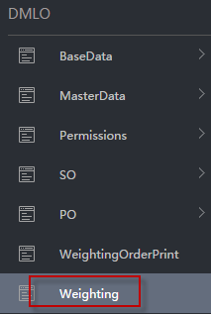

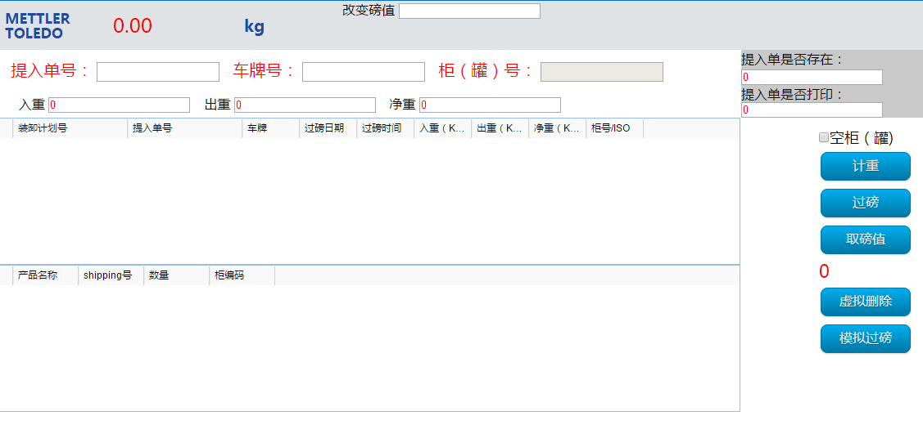

### 2. 空柜/空ISOTANK入厂和出厂

#### 空柜/空ISOTANK入厂

##### tick “空柜(罐)”

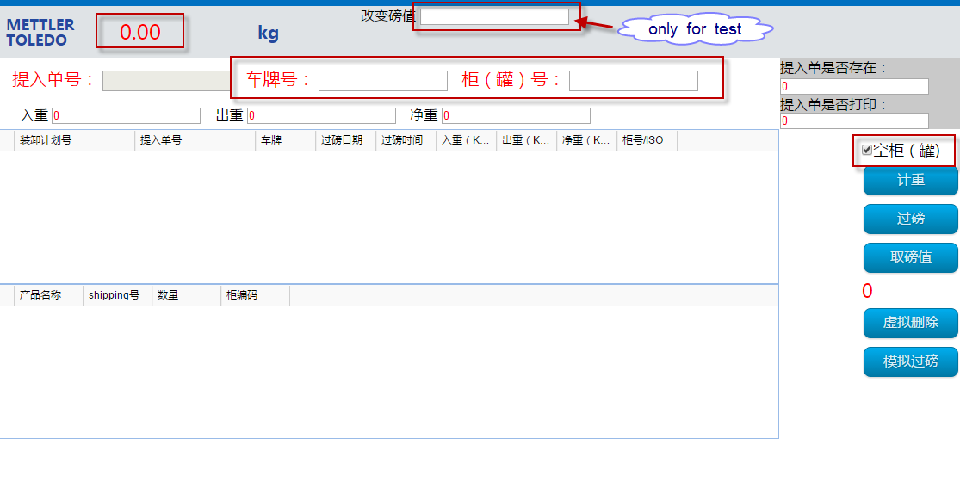

##### Input “Car Number” and “ContainerNO/ISOTANK NO”

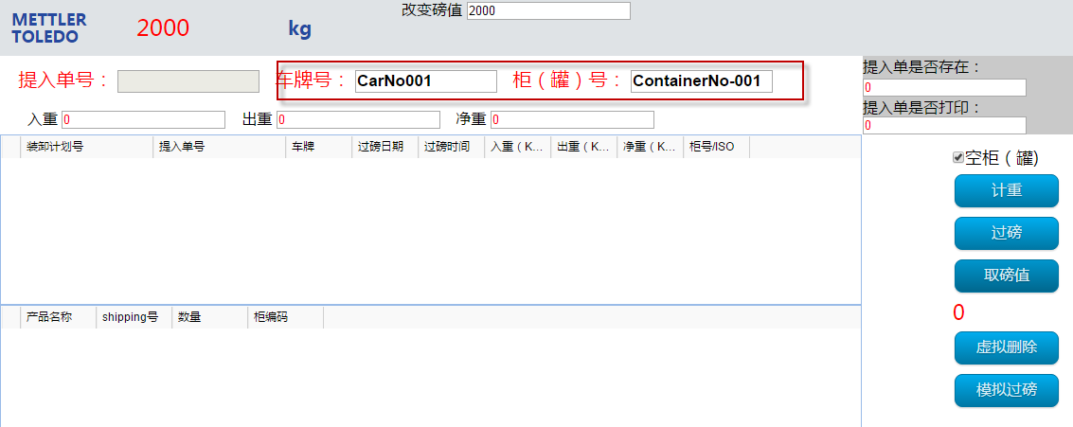

##### Click “取磅值”

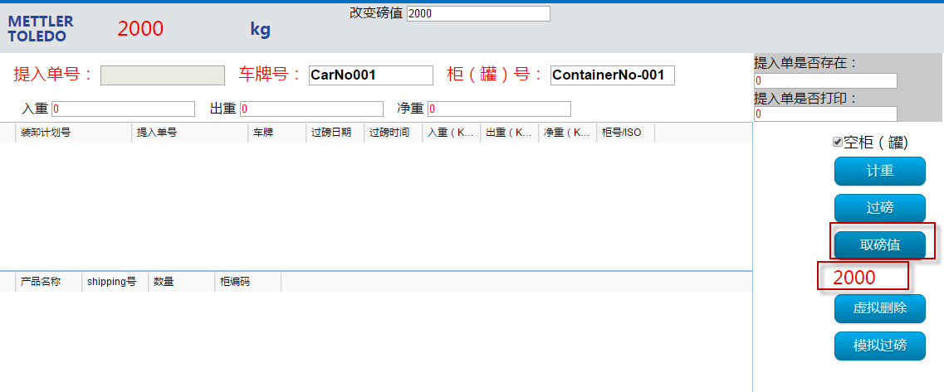

##### Then click “计重”， message “success”.

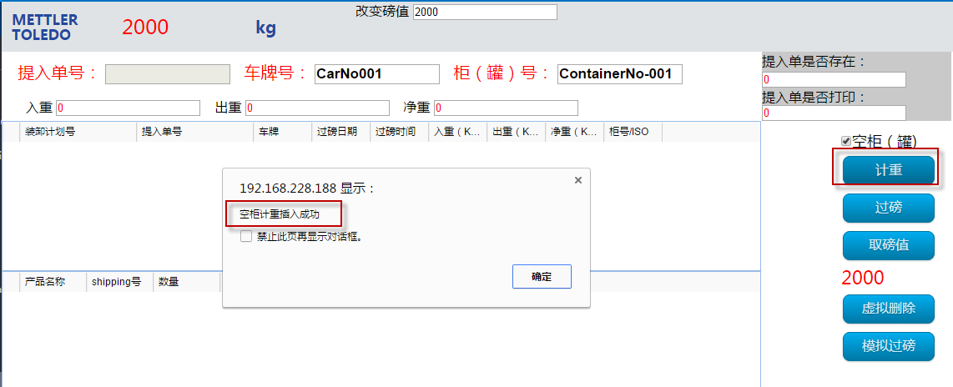

##### And show date /time/weight

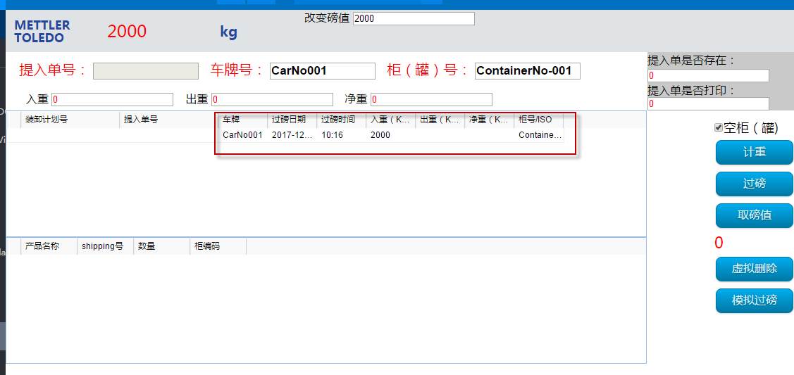

#### 空柜/空ISOTANK进入工厂后，空车出厂

##### tick “空柜(罐)”

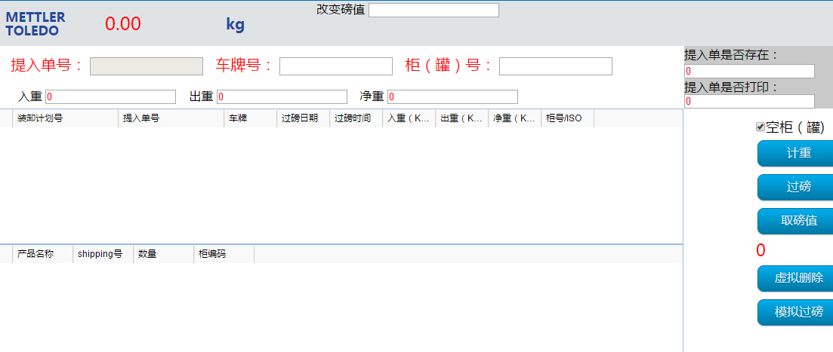

##### Key in “Car Number” and Enter, show info

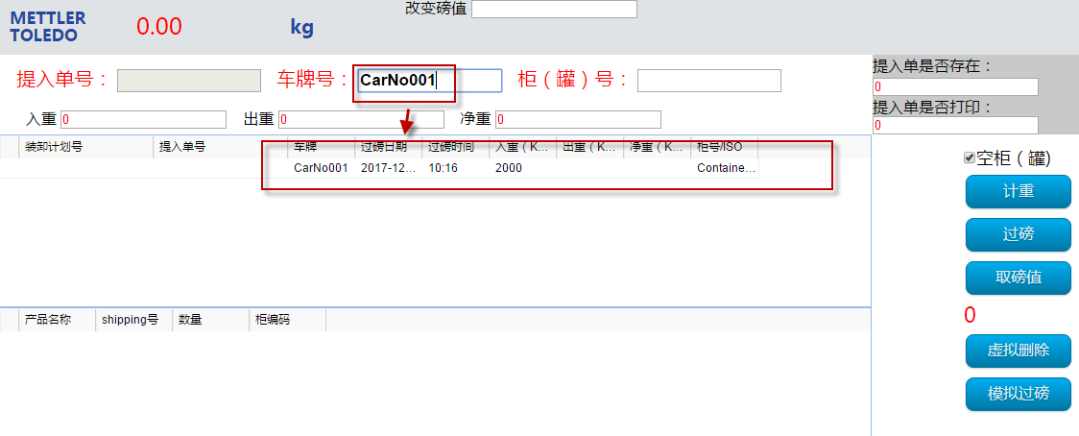

##### Click “取磅值”

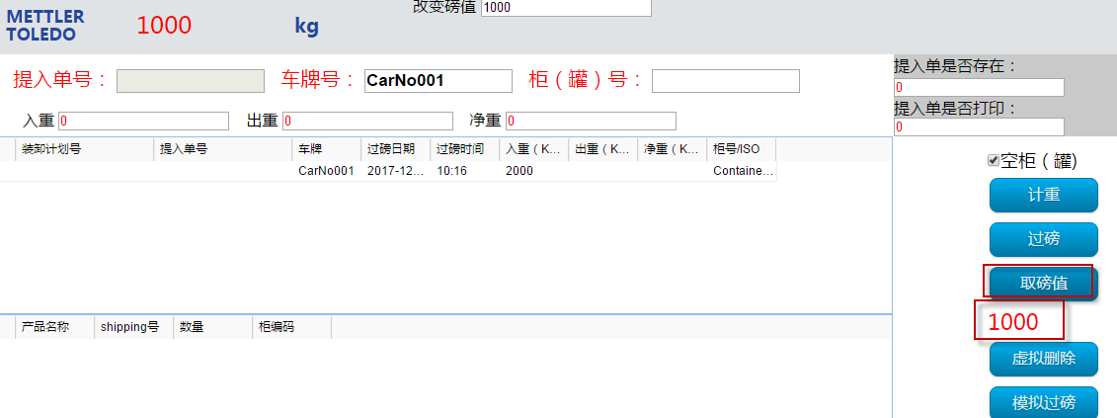

##### Then click “过磅”， message “success”.

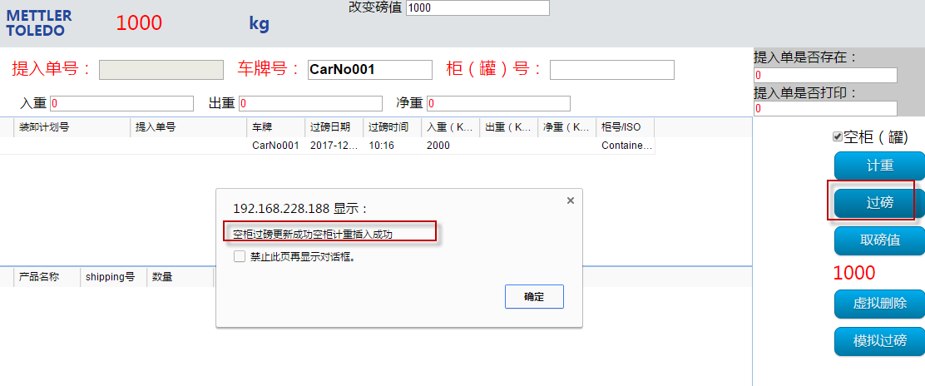

And show date /time/weight， and the Neight Weight of ContainerNO/ISOTANKNO

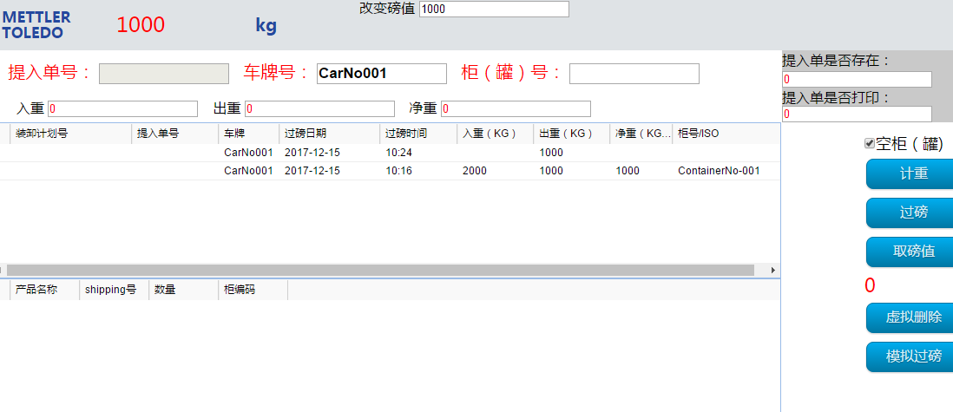

### 3.SO Weighting Order入厂和出厂

空车进，重车出

文件组提供Weighting Order Number

#### 车辆进厂

##### Key in Weighting Order Number, enter

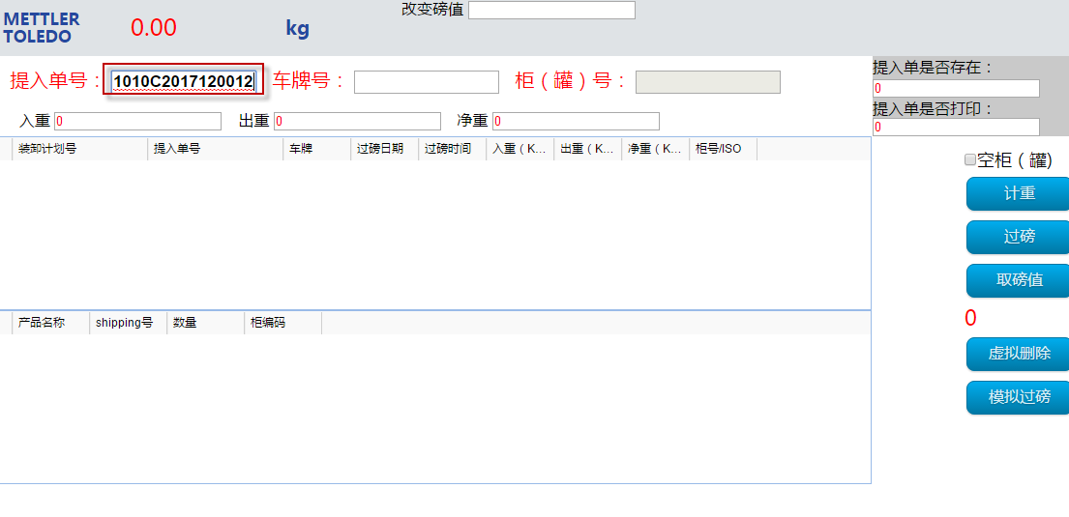

##### Show message “装卸计划中车牌为空” Loading/Unloading Plan without car number

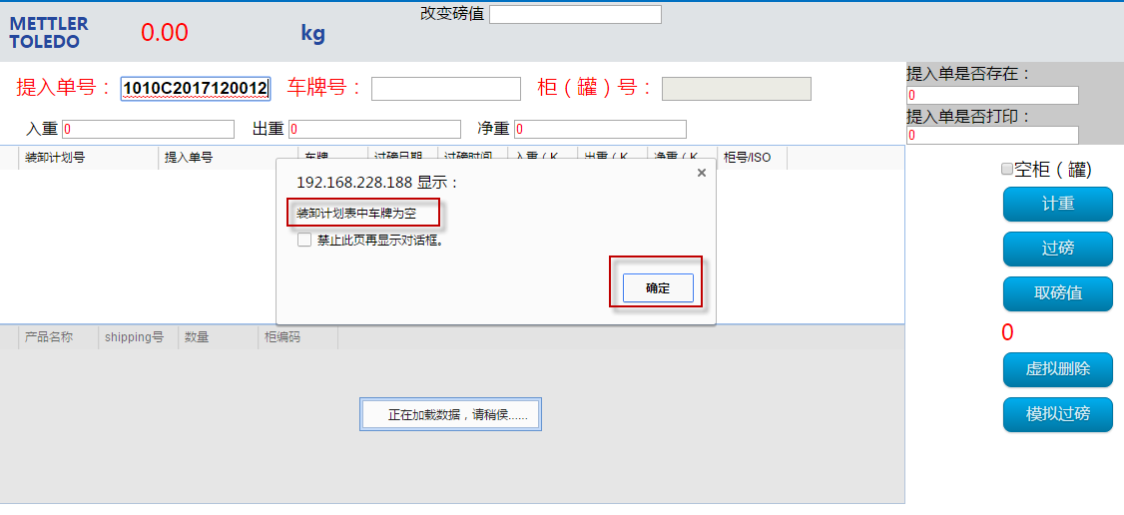

##### Show product details

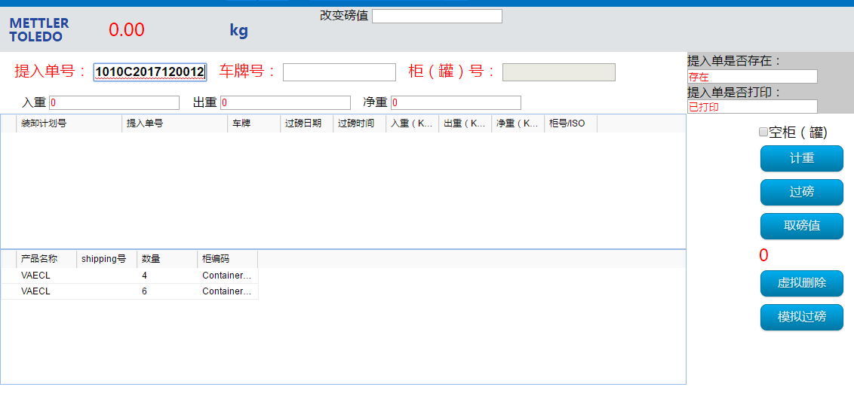

##### Key in Car Number

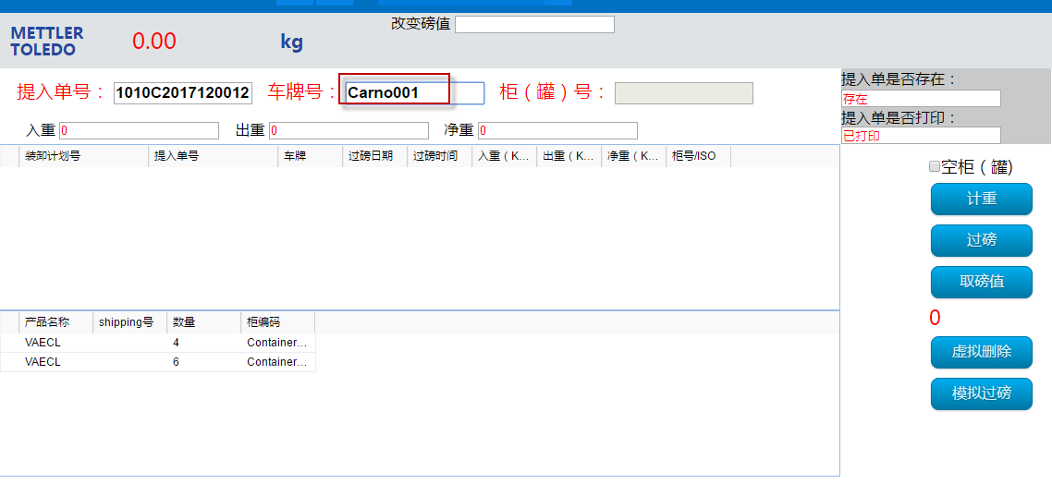

##### Click “取磅值”

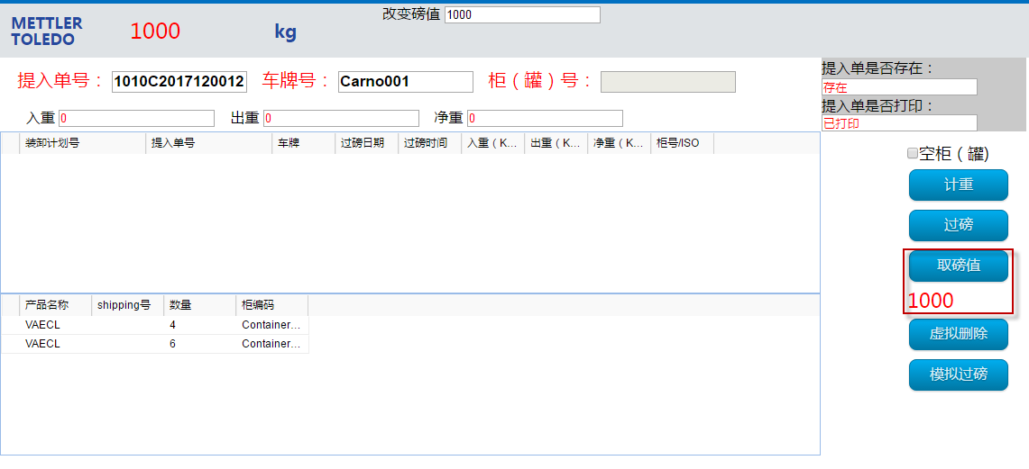

##### Then click “计重”， message “success”.

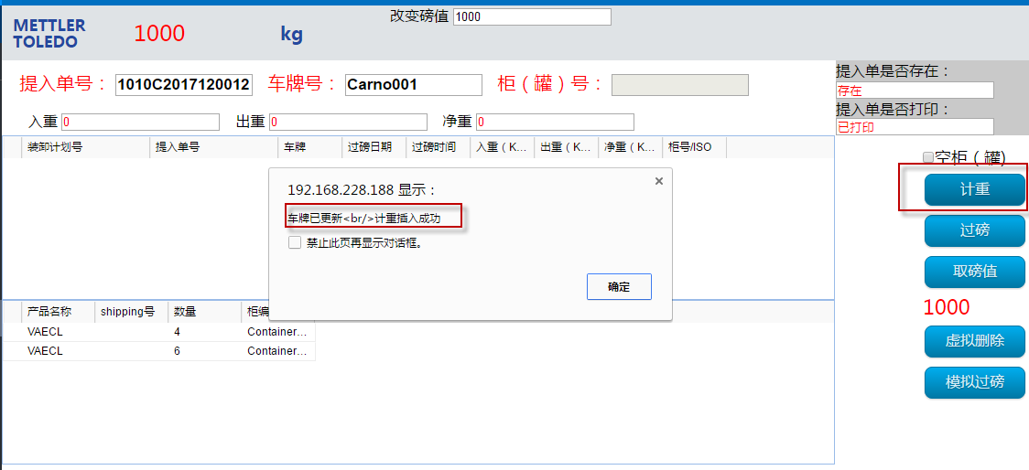

##### And show date /time/weight

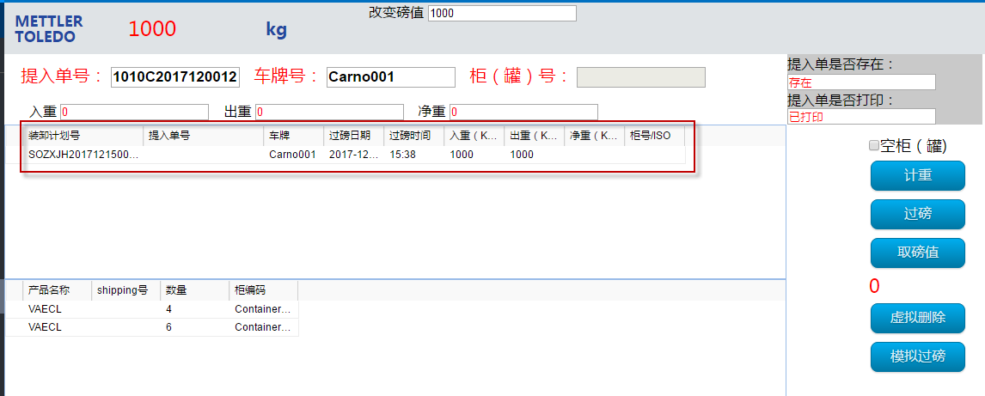

#### 仓库按StuffingOrder装货后，车辆出厂

##### Key in Weighting Order Number, enter

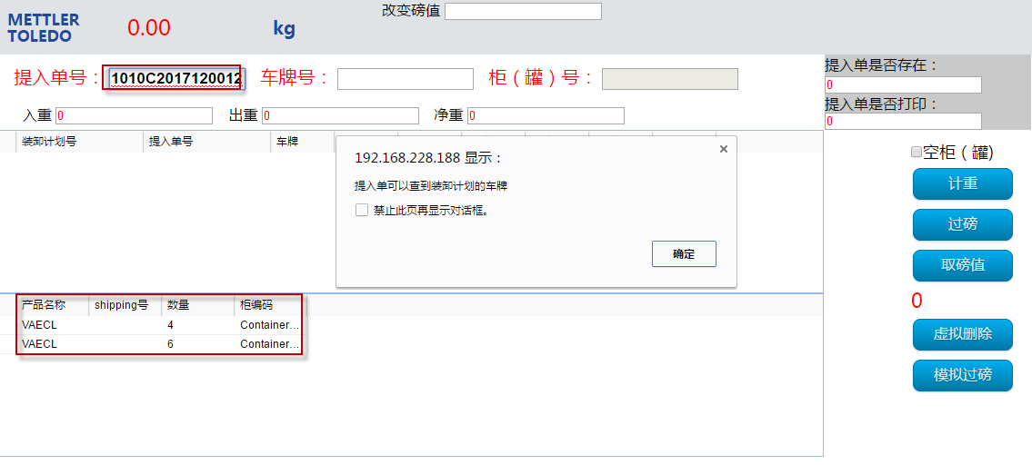

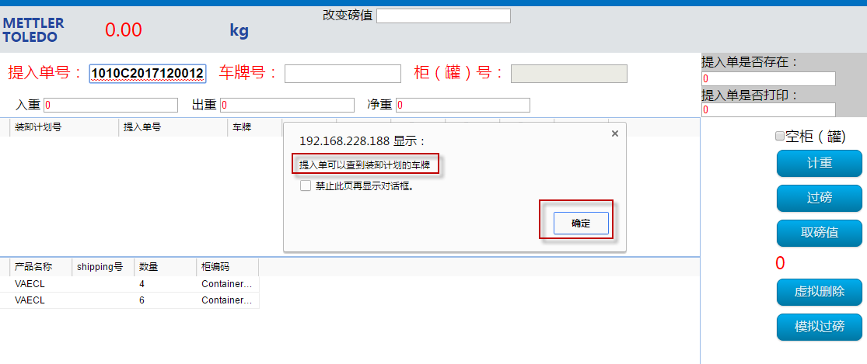

##### Show incoming weighting information

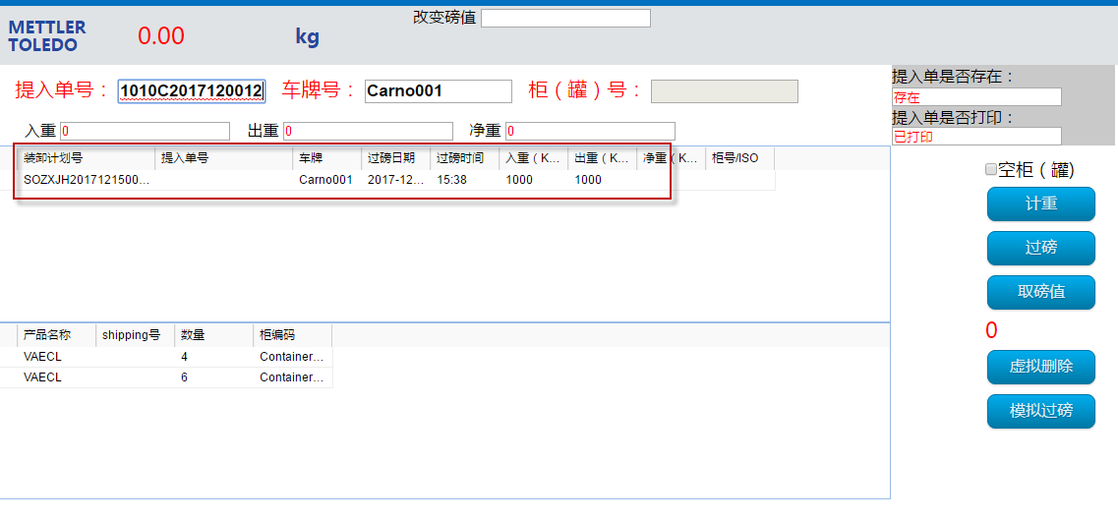

##### Click “取磅值”

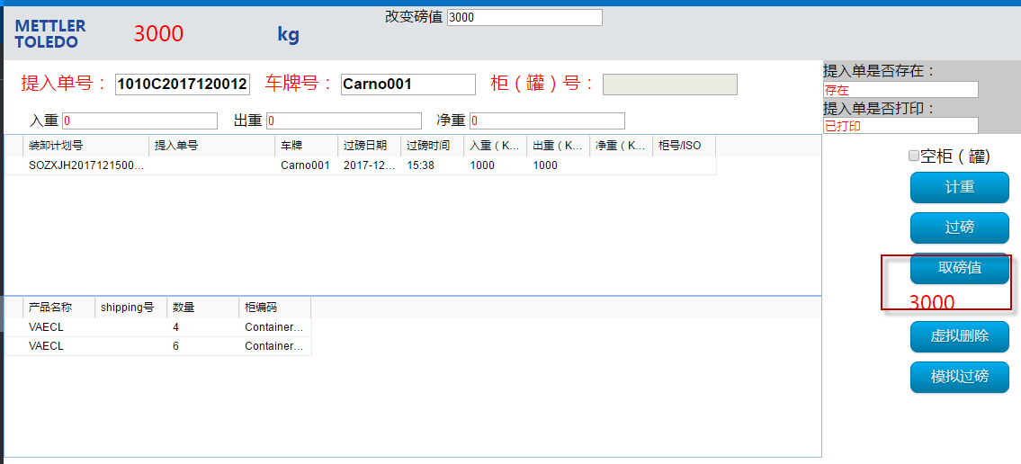

##### Then click “过磅”， message “success”.

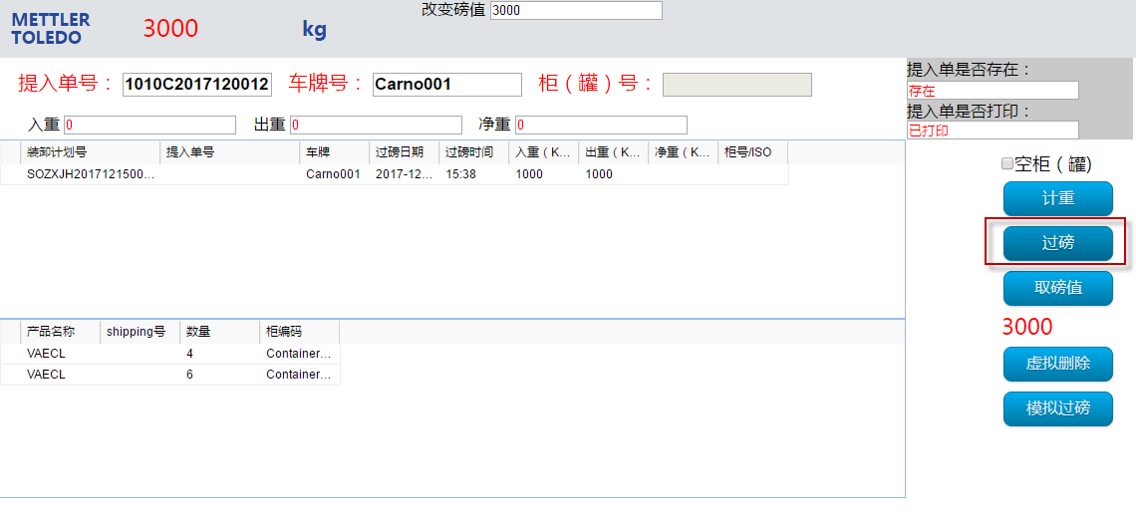

##### Key in Weighting Order Number, enter. You can check incoming and ongoing weighting Log

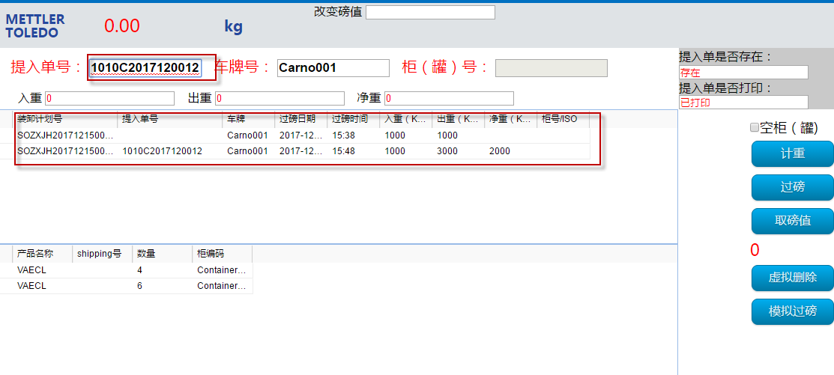

### 4.PO Weighting Order入厂和出厂

重车进，空车出

文件组提供Weighting Order Number

#### 基本同3.SO Weighting Order入厂和出厂， 略